Environmental Ministries and our new decade 2020
The earth is the Lord’s and all that is in it Psalm 24:1
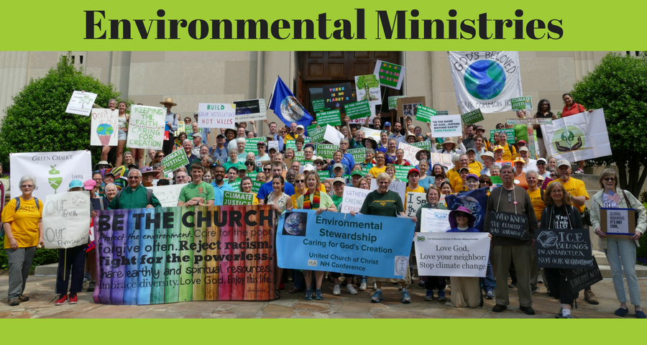

Take the UCC Environmental Justice Quiz!
1. Did you know that UCC ministers coined the phrase “environmental racism” and played a leading role in giving birth to the environmental justice movement in the 1980s? During a six week campaign of civil disobedience in 1982, a movement was born that made national headlines and introduced the world to the issue of environmental racism. Learn more about this inspiring movement in which the UCC became the driving organizational force.
2. Did you know that the UCC has formed a special partnership with a leading climate organization called 350.org, so that church green teams are now becoming 350 affiliates? Members of the United Church of Christ have often worked with 350.org in the pursuit of justice and shared goals. This informal, longstanding relationship is now being deepened through a pilot endeavor that encourages and invites UCC green teams to affiliate with 350. Read about this exciting undertaking.
3. Did you know that in places like Flint and Standing Rock the UCC has been actively involved in standing alongside those struggling for justice? Solidarity is one form that love takes in the ministry of environmental justice. The goal is to find ways local churches and members can actively support others who are facing environmental injustices. Read more about this important part of our work together.
4. Did you know that the UCC is building a powerful environmental network that stays connected through a blog and e-newsletter called The Pollinator? The Pollinator is a digital platform of the UCC for the sharing of ideas and inspiration, so that we might become more fruitful in the pursuit of environmental justice. Its focus is the building of a faith-filled and faith-rooted movement for the care of creation. Read the Pollinator blog and sign-up for its newsletter.
5. Did you know that UCC churches are deepening and expanding their commitment to the environment by becoming Creation Justice Churches? Whether it is taking on climate change or addressing the lead poisoning of children, environmental justice ministries could not have a higher purpose or calling than they do now. Join the movement and become a Creation Justice Church. Learn about the six steps for doing just that.

Upcoming Events
- January 9th Thursday 5:30 to 7 pm Community Supper - Bring a friend or yourself, be ready to savor a good meal, and enjoy your community! Don’t let food sensitivities keep you home – Each community supper has a gluten-free, dairy-free, and nut-free entrée for our special guests. Bring something canned or boxed for our local food pantry at St Vincent De Paul, and put it in the bin near our side entrance—and thank you.
- January 11th 3:30pm Nashua Soup Kitchen Meet in the church parking lot at 3:30 for carpooling to Nashua. We are usually back by 6:30 or 7pm. Share your love and energy in this outreach mission of our community. Contact Kathy Chapman, chapman.kathy@gmail.com or 878-4993 if you plan to go or need information. We welcome members of the community in this service mission.
- Jan 12 after worship service for the undecorating of the church Help us as we take away some pine needles and pack away our Christmas celebration items for the next year.
- January 18th 6:30 pm. Living Room Coffee House. Sign up for open mic, for music, or poetry reading, share in the food offerings before the music starts at 7 pm. https://thelivingroomcoffeehouse.wordpress.com/
- January 22nd Have your committee reports to Dotsie at dotsiemill@gmail.com by this date. She gets many blessings and accolades for her spiffy Annual Report but nothing can happen until she gets the content!
- Baptism on January 26th Curt Dunn’s great grandson baptism, Weston. Mark and Amanda will be bringing Weston for our community of faith to bless, and this will occur during worship service.
- Check out this link for an inspirational read from Rev Liz Goodman of Monterey UCC: file:///C:/Users/Owner/Downloads/Monterey%20News%20January%202020.pdf Read the contents at the beginning of the Monterey News to find Rev Liz’s message.

Community Volunteer Transportation Company (CVTC) is in your neighborhood! Call: get a ride or get information about volunteering to be a driver. (877) 428-2882 Just an hour or two of your time per week, or even per month, can make a big difference in a person's life. When you volunteer to be a driver for CVTC — taking neighbors to nonemergency medical or social service appointments, the grocery store, banking, or pharmacy — you increase the health of the entire region, one person at a time. Volunteer drivers donate their time, at their availability, and can choose to be compensated for their mileage. Community Volunteer Transportation Co. is a nonprofit providing no-fee rides for individuals without access to transportation due to age, ability, income, and/or life circumstance. To give or get a ride, visit cvtc-nh.org or call 1-877-428-2882, for more information. Thank you!

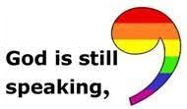 Remember our church family in your prayers, and in person with a visit, a call, or a card. Loneliness can be relieved, at least temporarily, and price of this “gift” is mostly free!
- Halbrooks family is moving to Jaffrey! They have purchased a larger house with an in-law apartment so Beth’s mother and father can join them. They won’t be moving til mid-January, but we already miss them, just thinking about the move.
- Curt Dunn Curt is at the rehab center Courville, 44 West Webster Street in Manchester. Although he has trouble reading, he still loves cards, but of course, enjoys calls and visits even more. As with his many neighbors in Courville, his health is fragile, so don’t bring any germs with you! Courville phone is 647-5900
- Gary Corning and Barbara These two reliable, steady members of our community are going through some challenging times. Gary has headed off cancer more times than you can imagine—and we attribute that to his faith, his good humor, his energetic and loving wife, and his healthcare team. You can reach them at 246 Old Ashby Rd, Mason barbaracorning246@gmail.com or 878-4909
- Lisa and Brian Charbonneau, 130 Jeds Lane, Mason, NH 03048 878-1502. Welcome to Mason Church!
- Susan and Jim Suokko have moved to Leominster, MA. Their new address is: 50 Brooks Pond Rd, Apt 104, Leominster, MA 01453. They will be attending a church near their home, and as usual will be in Florida during the winter months.
- Laila Washburn This is Laila’s 101st year! Laila lives at Summer Hill Assisted Living in Peterborough. She loves company and cards. At her age every day is treasured. Laila Washburn, Summer Hill, 183 Old Dublin Rd, Peterborough, NH 03458. Call ahead if you have questions. 603-924-6238
- Gretchen and Wally Brown Always in need of a little cheer, and Gretchen needs contact with the outside world, so stop by with a smile, a meal, or just to pick up syrup and say hello!
Cards to: 421 Meetinghouse Hill Rd, Mason, NH 03048 phone: 878-1481
- Forty Family Daughter Meredith and family moved to Manhattan. We wish them well, and hope they will come home to Mason often.
- Peggy Lee Welcome to Peggy who worshiped with us last week, and shared our coffee hour social time. She lives in New Ipswich, so help her meet Jean Randle and Helen Emma when she comes again.
- Thank you to everyone who helps with our coffee hour after worship—what great hosts you all are!

Only by discussing our differences openly, honestly, and with civility can we honor the intentions of the framers of the Constitution who gave us the first system of government that regards conflict not as the enemy of a good social order but as the engine of a better social order—if we hold our conflicts creatively. This work does not have to be done in large-scale public forums, but can and should be done in smaller versions: the family, a friendship, a neighborhood, a congregation.
Parker Palmer in On the Brink of Everything

